



Implementation of Comparison Operators in Python
LAB MANUAL

Disclaimer: The content is curated from online/offline resources and used for educational purpose only
Implementation of Comparison Operators in Python
Objective:
To understand and demonstrate the use of comparison operators in Python through practical examples.
Problem Statement:
Comparison operators are used to compare values in Python. These operators return a boolean result (True or False) based on the condition being evaluated. This lab manual demonstrates the implementation and usage of comparison operators in Python.

Equipment Required:
- Install VS Code - https://code.visualstudio.com/download
- Download Python Installer File - https://www.python.org/downloads/
Prerequisites:
- Basic Computer Skills - Anyone starting to learn computer programming needs basic computer skills. Python is a cross-platform language, so it makes no difference whether you use a macOS, Windows, or even Linux.

Procedure:
Code:
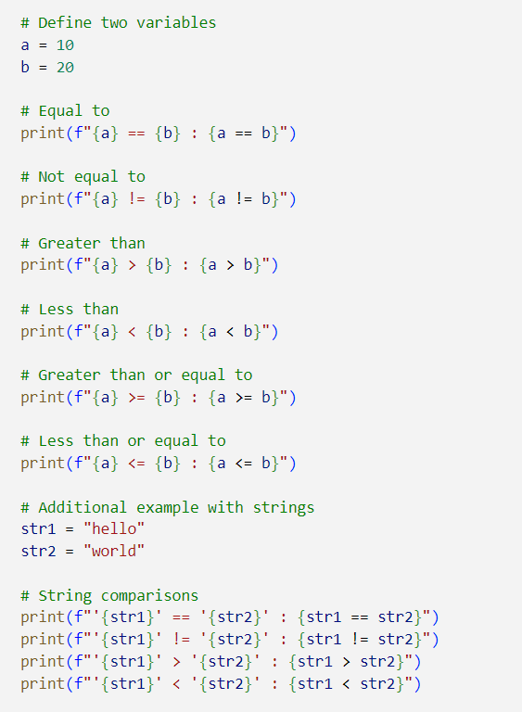

Output:
